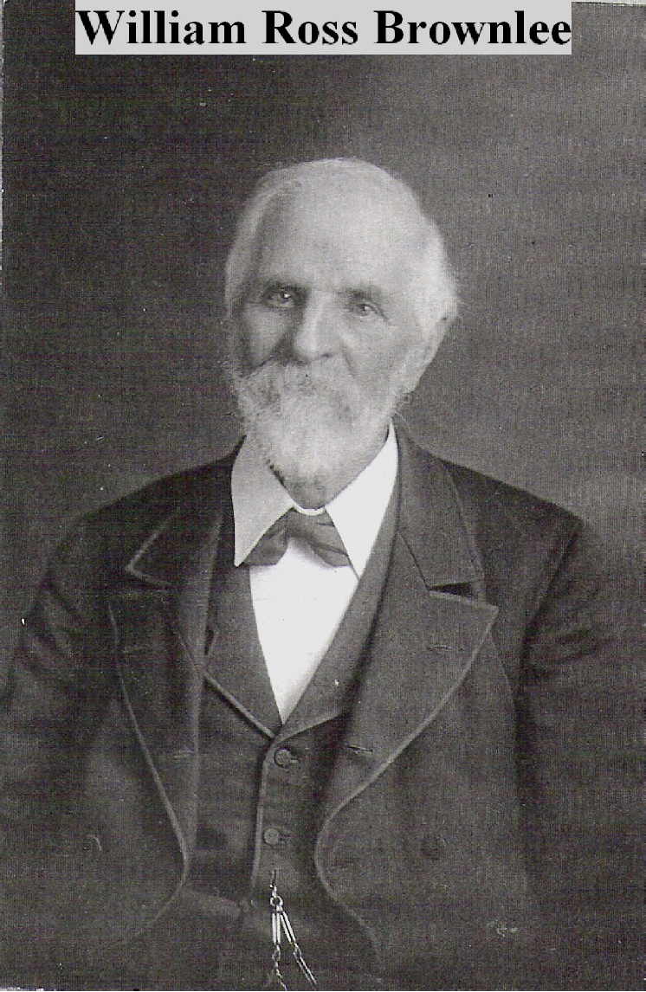

Image supplied by Claire Brownlee Smith – granddaughter of William Ross Brownlee. William Brownlee is probably in his eighties.

